

**ANSWER 1:**

**CODE:**

using System;

namespace ConsoleApp1

{

class Students

{

public string name;

public int rollNumber;

public int phoneNumber;

public string address;

}

class Program

{

static void Main(string[] args)

{

Students s1 = new Students();

s1.name = "Furqan";

s1.rollNumber = 12067;

s1.phoneNumber = 056373567;

s1.address = "Malir";

Students s2 = new Students();

s2.name = "Umer";

s2.rollNumber = 12077;

s2.phoneNumber = 043623457;

s2.address = "creek";

Console.WriteLine( "Student one" );

Console.WriteLine(s1.name);

Console.WriteLine(s1.address);

Console.WriteLine(s1.rollNumber);

Console.WriteLine(s1.phoneNumber);

Console.WriteLine("-----------------");

Console.WriteLine("Student one");

Console.WriteLine(s2.name);

Console.WriteLine(s2.address);

Console.WriteLine(s2.rollNumber);

Console.WriteLine(s2.phoneNumber);

Console.WriteLine("-----------------");

Console.ReadKey();

}

}

}

OUTPUT:

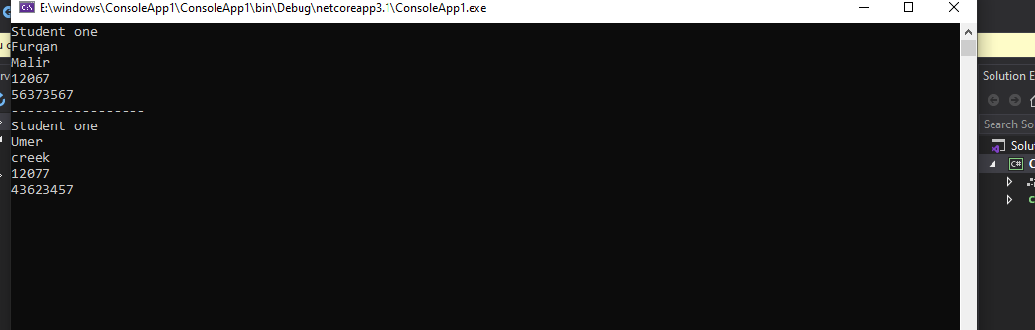

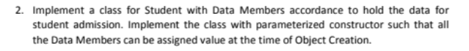

Answer 2:

CODE: 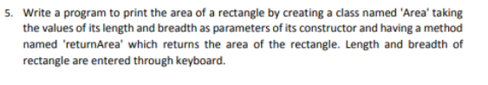

using System;

namespace ConsoleApp1

{

class students

{

private string name;

private int phone_number;

private string city;

public students(string Names,int phoneNumber, string cities)

{

this.name = Names;

this.phone_number = phoneNumber;

this.city = cities;

show();

}

private void show()

{

Console.WriteLine("Employee Name: \t"+ name +" Phone Number: \t" + phone_number+ " City: \t" + city);

}

}

class Program

{

static void Main(string[] args)

{

students std1 = new students("Areeb",01342341,"karachi");

students std2 = new students("Rafiq", 0323536362, "lahore");

students std3 = new students("Areeb", 013462341, "Multan");

students std4 = new students("Umer", 0334736362, "Peshawar");

}

}

}

**OUTPUT:**

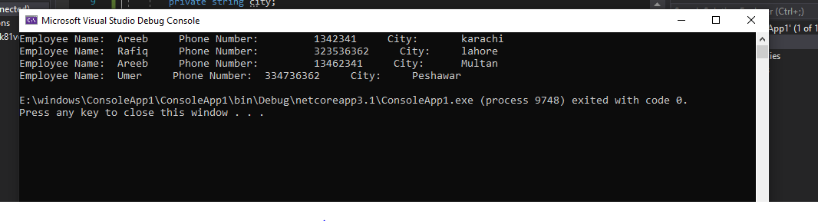

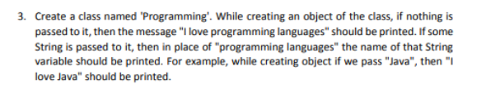

**ANSWER 3:**

**CODE:**

using System;

namespace ConsoleApp1

{

class Programming

{

public string a;

public Programming()

{

Console.WriteLine("i love Programming Language");

}

public Programming(string b)

{

this.a = b;

Console.WriteLine("i love "+b);

}

}

class Program

{

static void Main(string[] args)

{

Programming obj1 = new Programming("Java");

Programming obj2 = new Programming();

}

}

}

**Output:**

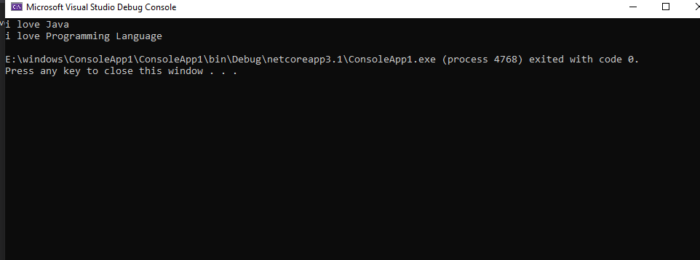

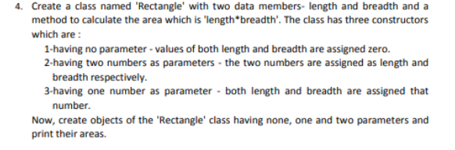

**ANSWER 4:**

**CODE:**

using System;

namespace ConsoleApp1

{

class Rectangle

{

public int length;

public int breadth;

public Rectangle()

{

this.length = 0;

this.breadth = 0;

Console.WriteLine(Area());

}

public Rectangle(int l, int b)

{

length = l;

breadth = b;

Console.WriteLine(Area());

}

public Rectangle(int num)

{

length = num;

breadth = num;

Console.WriteLine(Area());

}

private int Area()

{

return length * breadth;

}

}

class Program

{

static void Main(string[] args)

{

Rectangle rc1 = new Rectangle();

Rectangle rc2 = new Rectangle(15, 6);

Rectangle rc3 = new Rectangle(13);

}

}

}

**Output**

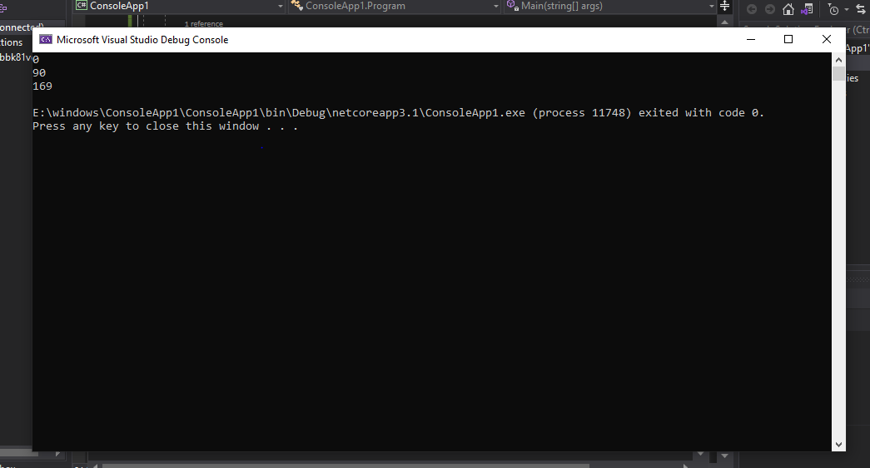



Answer 5:

Code:

using System;

namespace ConsoleApp1

{

class area

{

public int length;

public int breadth;

public area(int l, int b)

{

this.length = l;

this.breadth = b;

Console.WriteLine("Area of rectangle "+returnArea());

}

private int returnArea()

{

return length * breadth;

}

}

class Program

{

static void Main(string[] args)

{

Console.WriteLine("Enter Length");

int a = Convert.ToInt32(Console.ReadLine());

Console.WriteLine("Enter Breadth");

int b = Convert.ToInt32(Console.ReadLine());

area a1 = new area(a,b);

}

}

}

**Output:** 